Hotel Cookiemania

By Ridhwaan Ali

Table of Content

1. Description
2. Design
3. Implementation
4. Test Run
5. Conclusion

Description

My hotel is called “Hotel Cookievania”. I came up with the name fusing the famous movie “Hotel Transavania” and chocolate chip cookies. My objective was to make a hotel service as every other service. Clients check in and check out and it is stored inside a database. The database will store the information such as the rooms registered, the clients and the times they checked in and checked out. Notable this was created as a prototype more ideas for it will develop overtime.

Design

The design of the project is as simple as it gets. The simplicity was actually intended although there will be more designs implemented in the main course of the project. The website starts off with a welcome page which I titled the main.html. In it, it welcomes the user to the hotel and once the user clicks on the link it redirects them to the check in and check out page. In that page it will instruct the client to input their time and it will be stored into the database. If they are new it will redirect them to the page where they can register whatever room is available.

Implementation

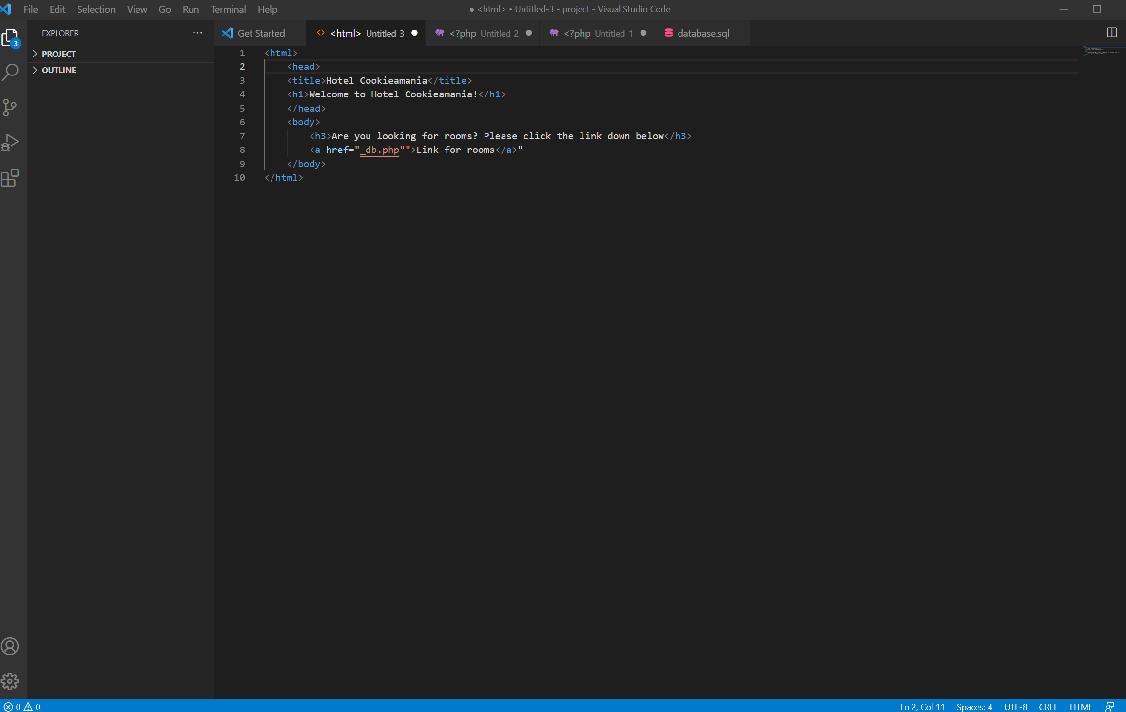

This is the main page or the welcome page. A basic html website with a hyperlink that redirects to the check in and check out page.

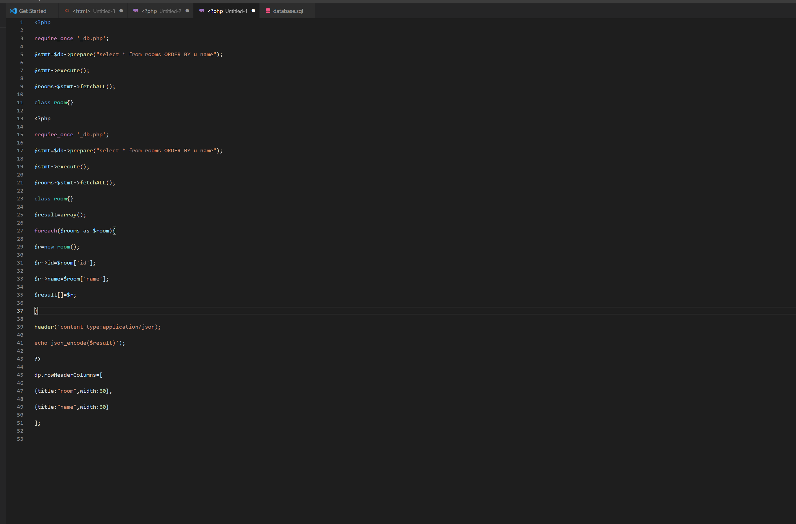

This is the check in and check out page that the main page redirects to. As shown there are tables and input values that are stored into the database.

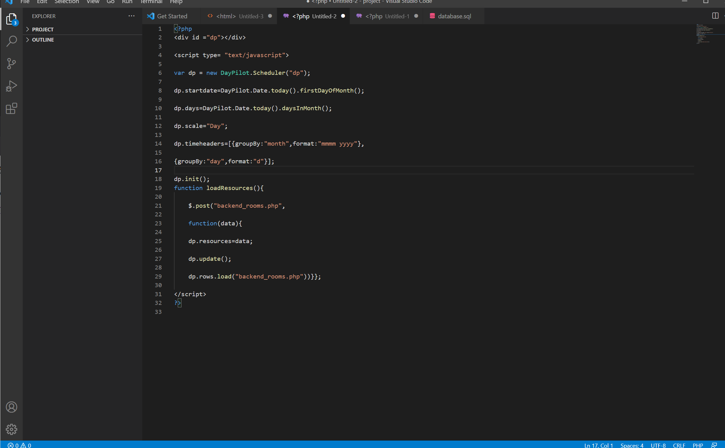

This is the database php itself where it checks the users from the database sql

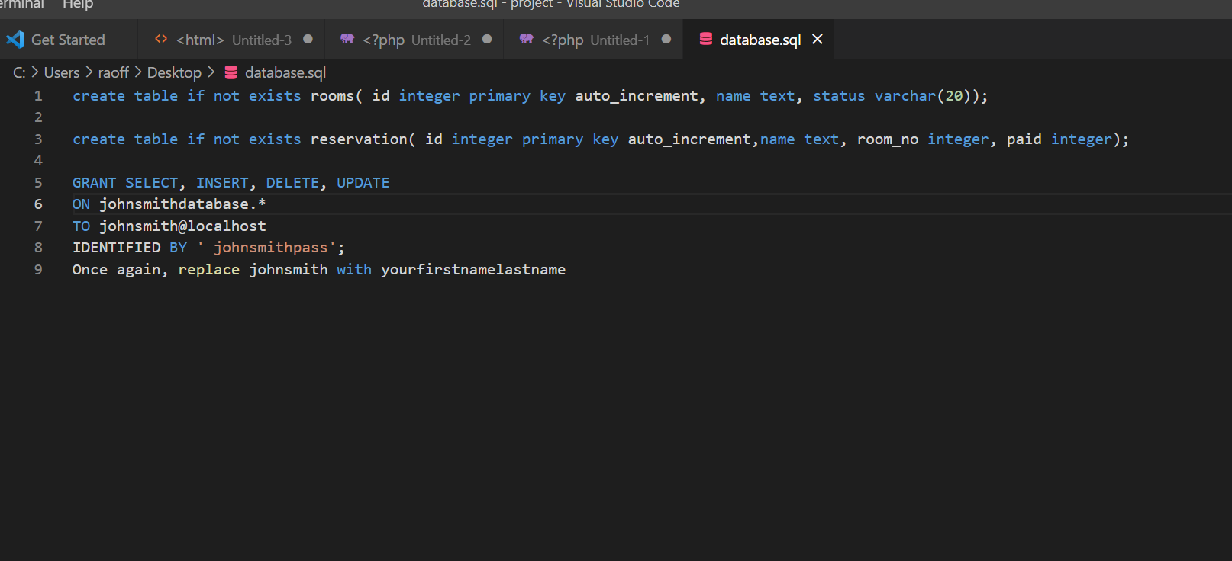

This is the database sql as shown the permissions are also given as well.

Test Run

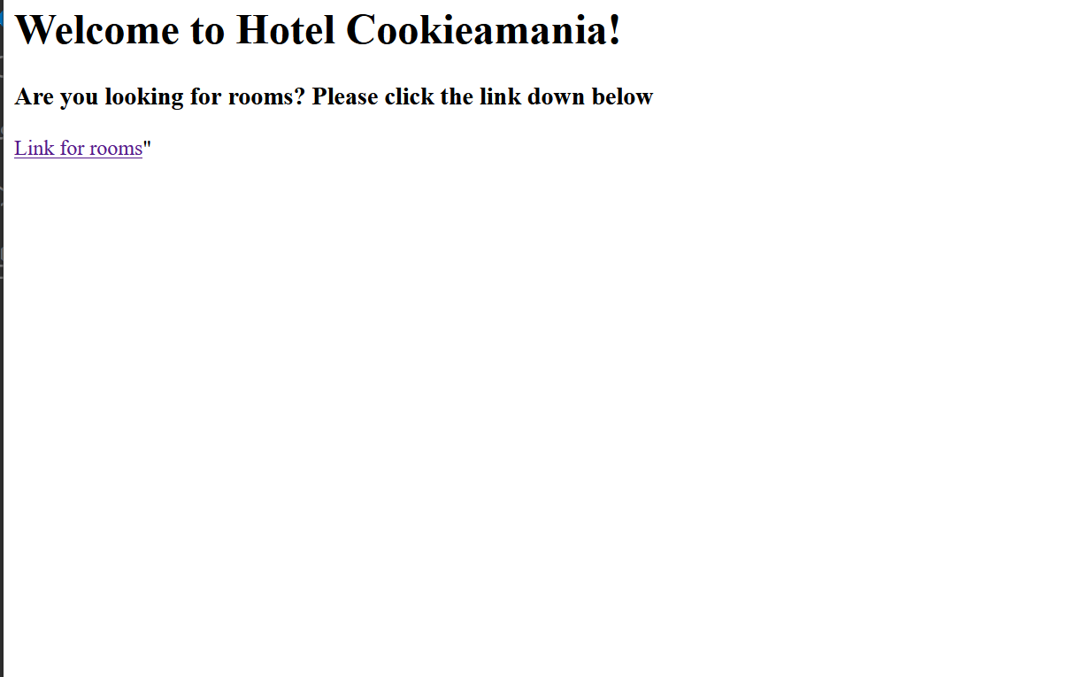

This is the main page. It isn’t designed colorfully because it is a prototype and the main purpose is the idea of it. However for the main project I would still keep it simple just to think about all the possible users that may use this.

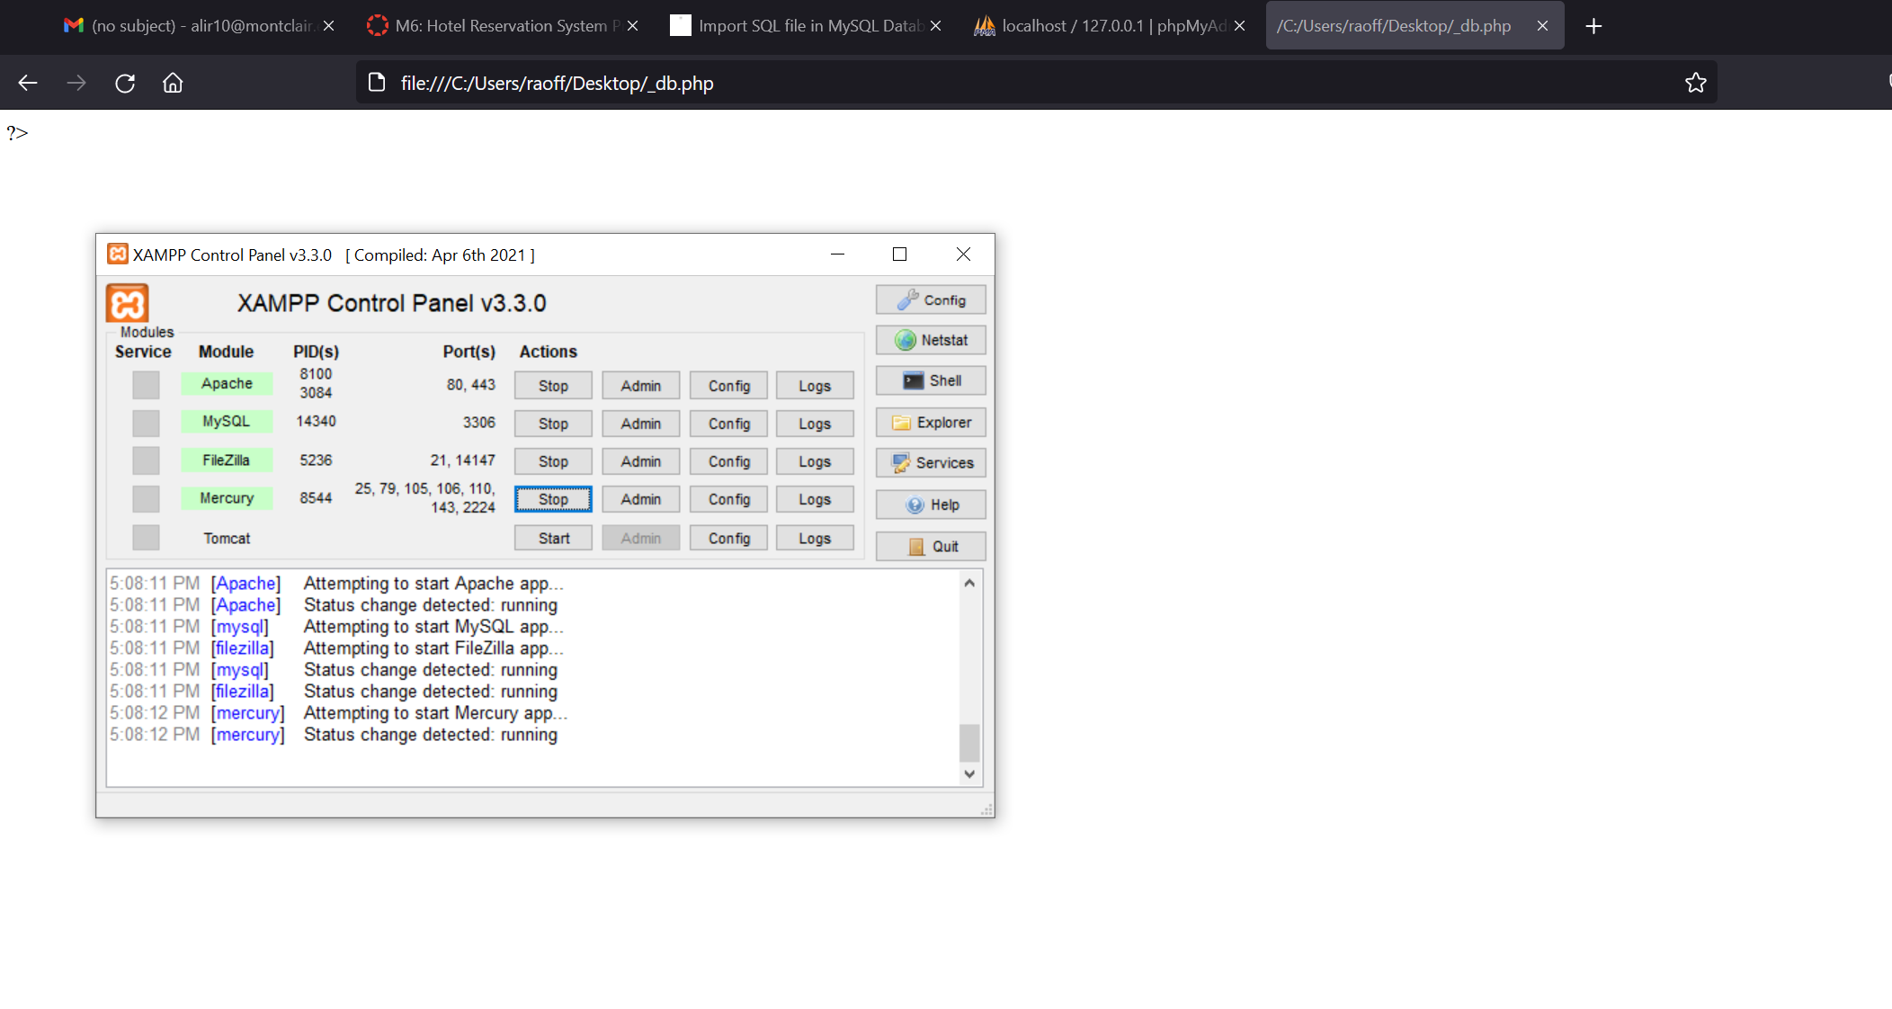

This is where my php portion is not functioning. This was supposed to be where the user is able to check in or check in for the first time.

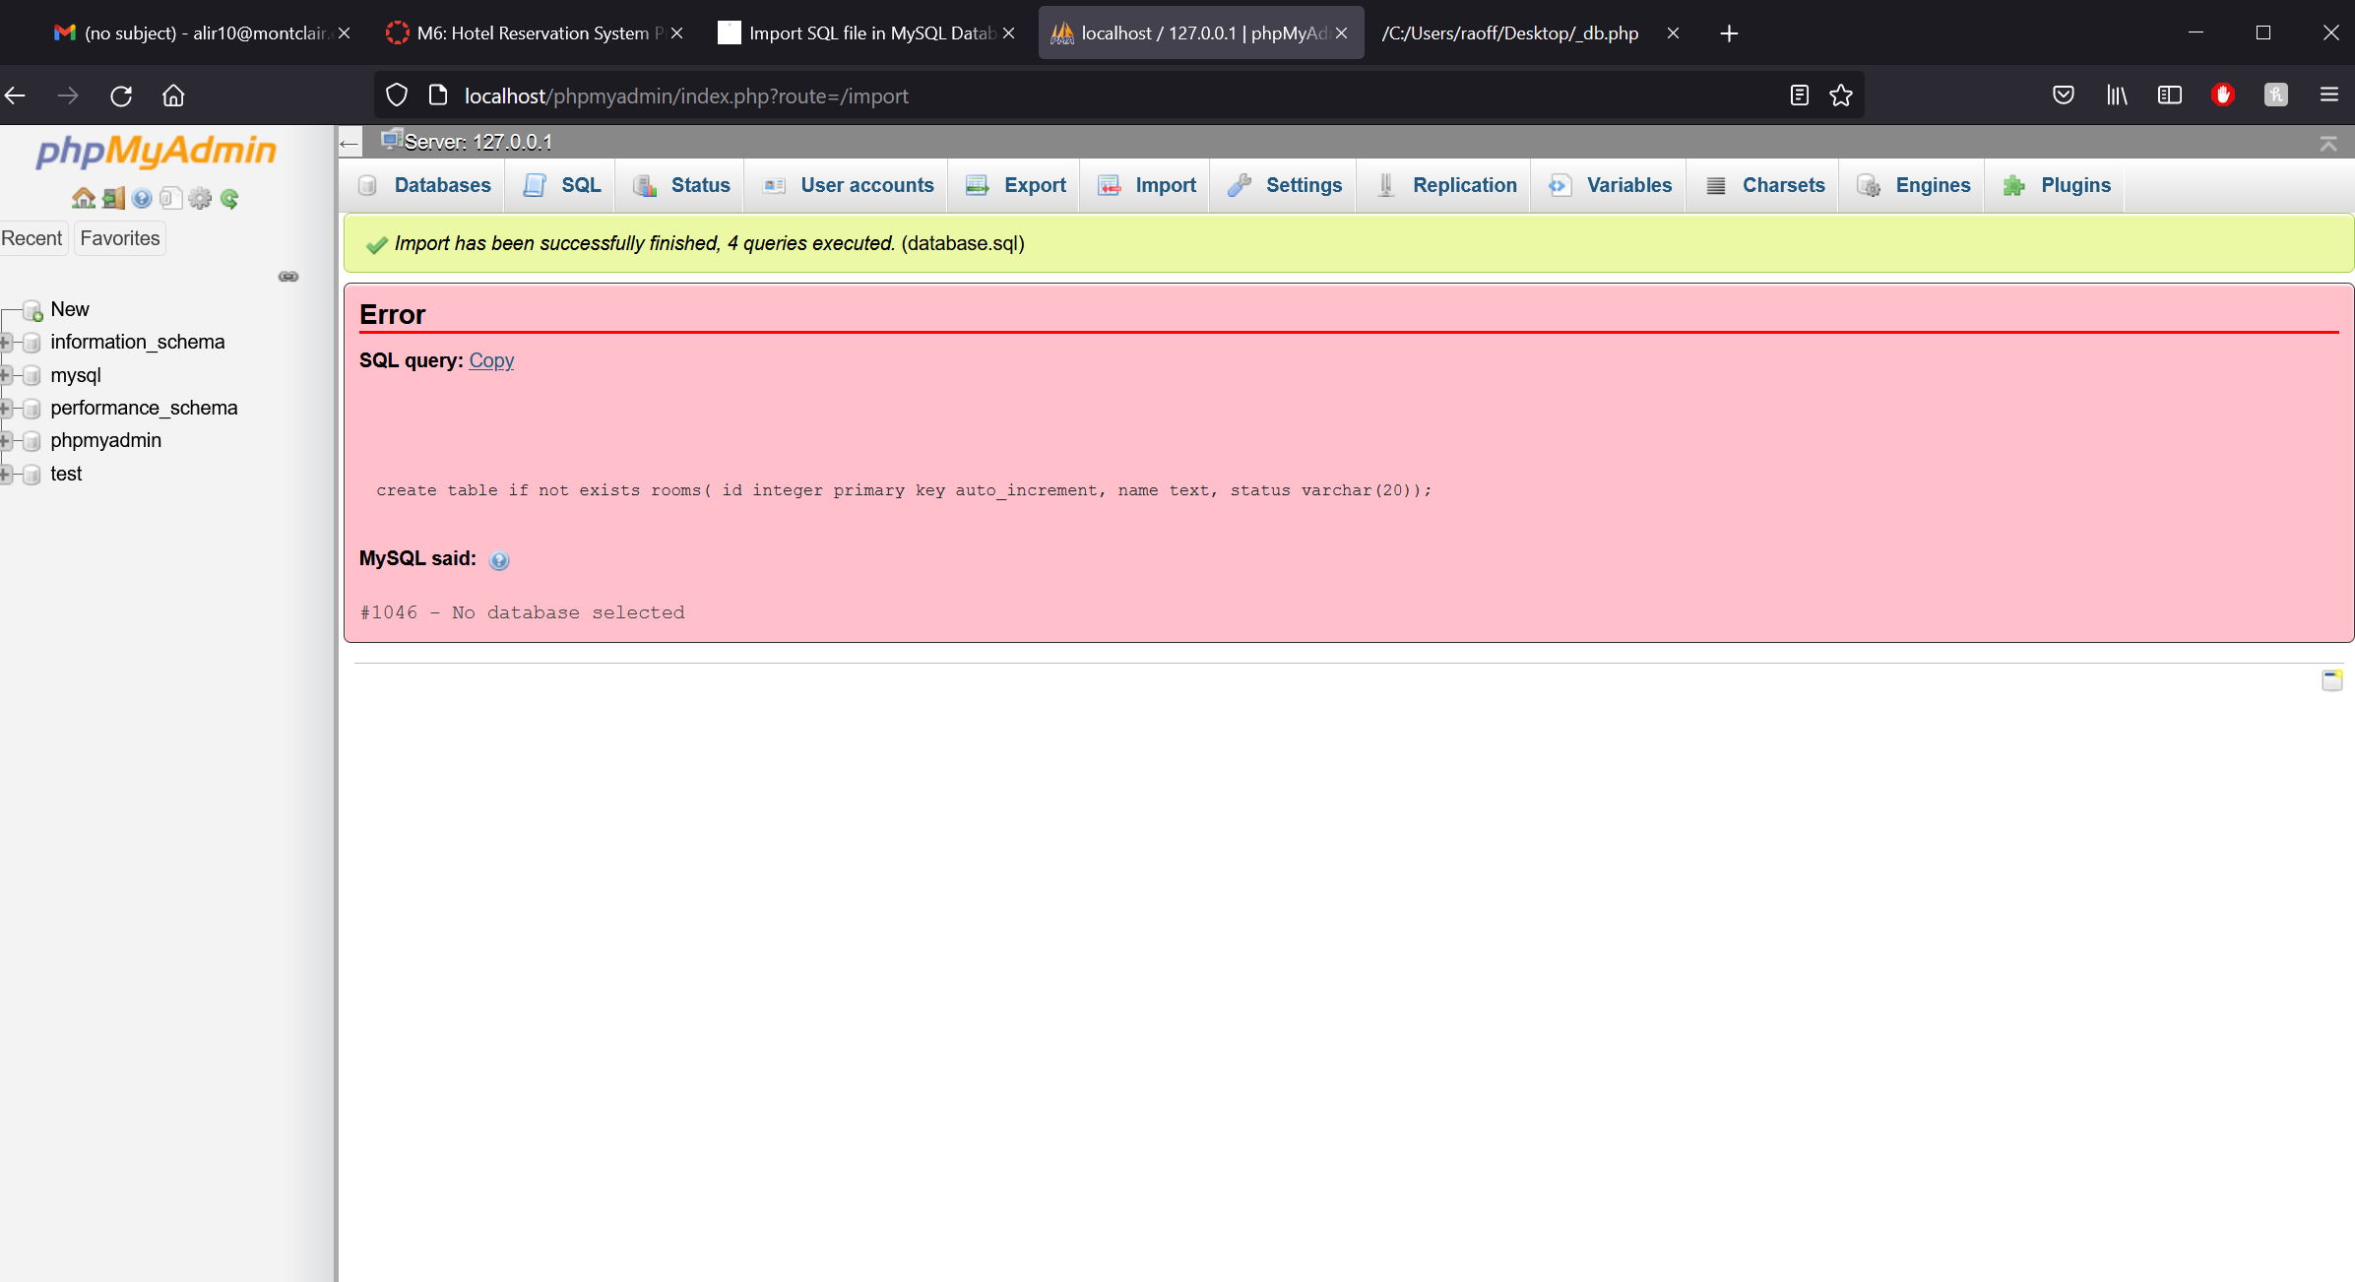

This was the sql file imported into the phpmyadmin it also was facing issues when importing into the system

Conclusion

I will discuss mainly on the things that will needed to be improved. The following need improvements: the php files corresponding better in terms of linking so that way it runs; the database errors that needed to be fixed such as proper matrix implementation so it is imported properly; and of course the overall design of the project. Overall the focus of this project was for me to implement the concepts for the hotel website. Although I wish it had been implemented a lot better, but as long as my idea is shown.